**DAILY ONLINE ACTIVITIES SUMMARY**

|  |  |  |  |  |  |  |  |  |
| --- | --- | --- | --- | --- | --- | --- | --- | --- |
| **Date:** | **28/05/2020** | | | | | **Name:** | **VIRESH** | |
| **Sem & Sec** | **4th SEM & ‘B’ SEC.** | | | | | **USN:** | **4AL18CS097** | |
| **Online Test Summary** | | | | | | | | |
| **Subject** | | **1)Microcontroller And Embedded Systems**  **2)Aadalitha Kannada** | | | | | | |
| **Max. Marks** | | **1)20**  **2)50** | | **Score** | | | **1)18**  **2)37** | |
| **Certification Course Summary** | | | | | | | | |
| **Course** | **Python for Machine Learning** | | | | | | | |
| **Certificate Provider** | | | **Greatlearning Academy** | | **Duration** | | | **5.0 Hrs.** |
| **Coding Challenges** | | | | | | | | |
| **Problem Statement:** C program to find digital root of a number. | | | | | | | | |
| **Status: Done** | | | | | | | | |
| **Uploaded the report in Github** | | | | | **Yes** | | | |
| **If yes Repository name** | | | | | **Lockdown-Coding**  <https://github.com/viresh-kulal/Lockdown-Coding/blob/master/triangularnumbers.c> | | | |
| **Uploaded the report in slack** | | | | | **Yes** | | | |

**Online Test Summary: Today 18CS44 test was scheduled from 12:00pm to 12:40pm .The portion for the IA was 2nd module, there were 20questions and the time assigned was 40 minutes the questions were MCQ type.**

**The snapshot of the completion of the test and the marks allotted is attached here.**

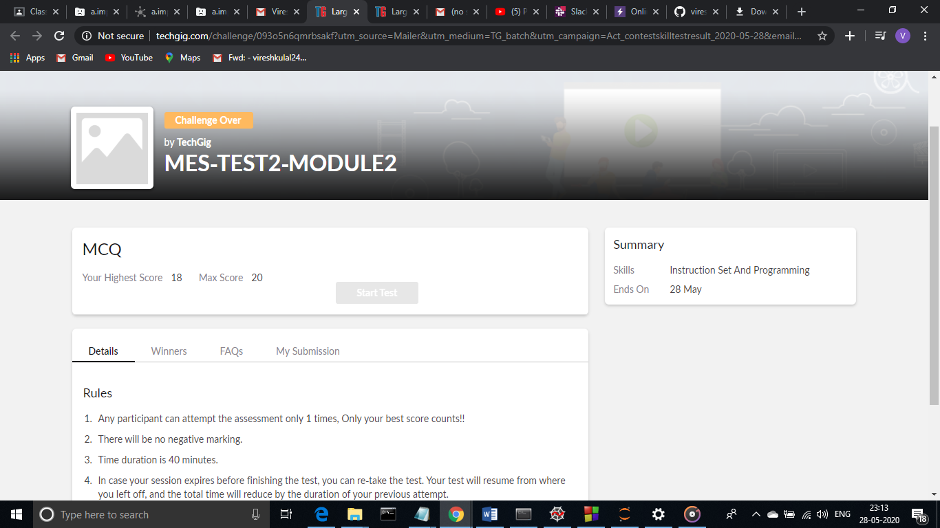

**Also 18KAK49 test was scheduled from 2:00pm to 2:50pm.The portion for the IA was all 10 chapters there were 50 questions and time assigned was 50 minutes the questions were MCQ type.**

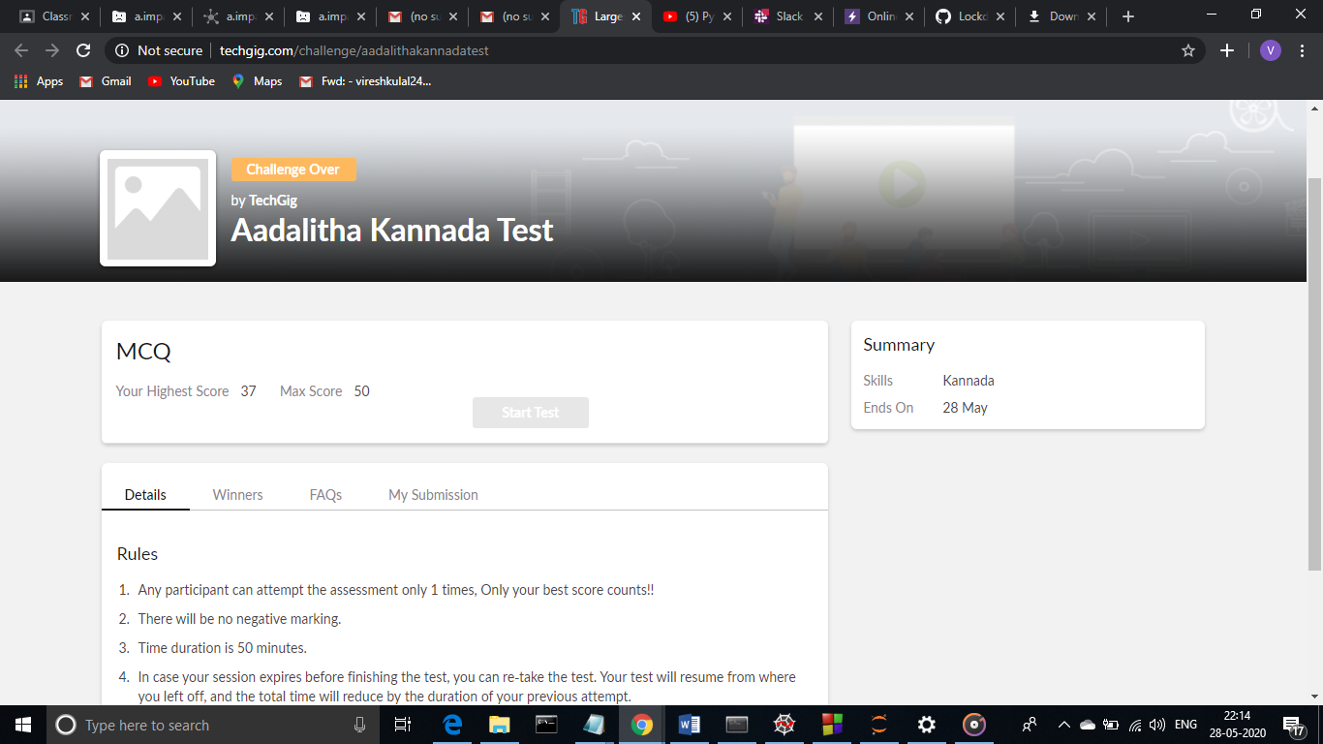**This is the completion of test and marks obtained for 18KAK49.**

**Online Certification Course Summary: In today’s session, I have continued the course with saving and loading data frames, user defined functions, lambda functions and their examples. And I have also learnt about the concept called classes & objects.**

**The snapshots of today’s session is attached below.**

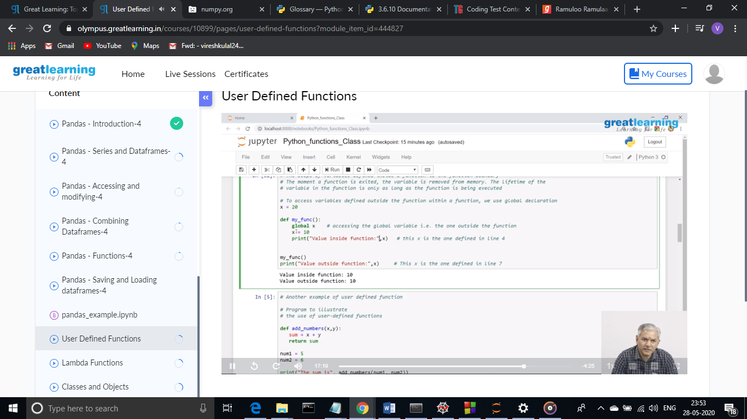

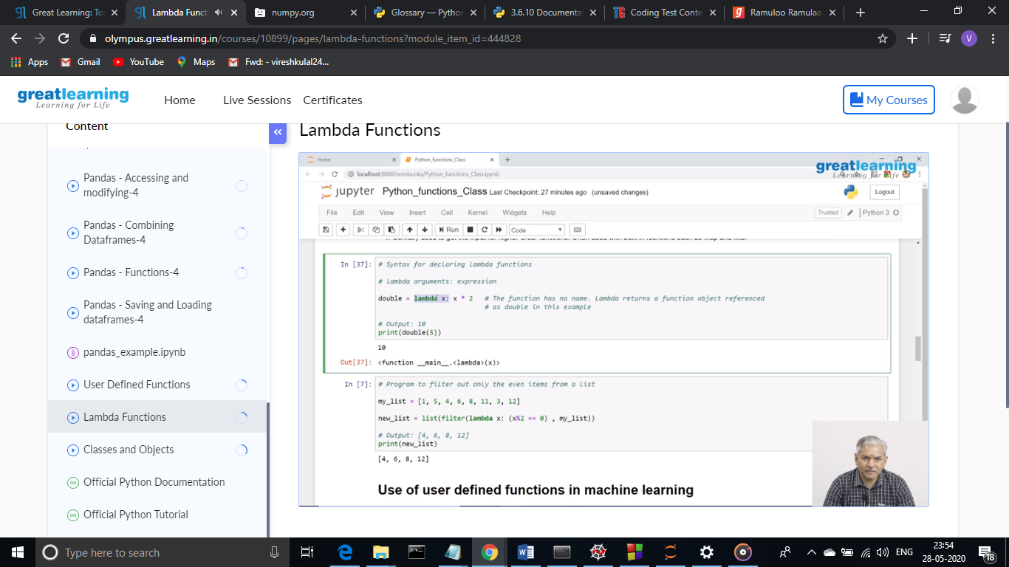 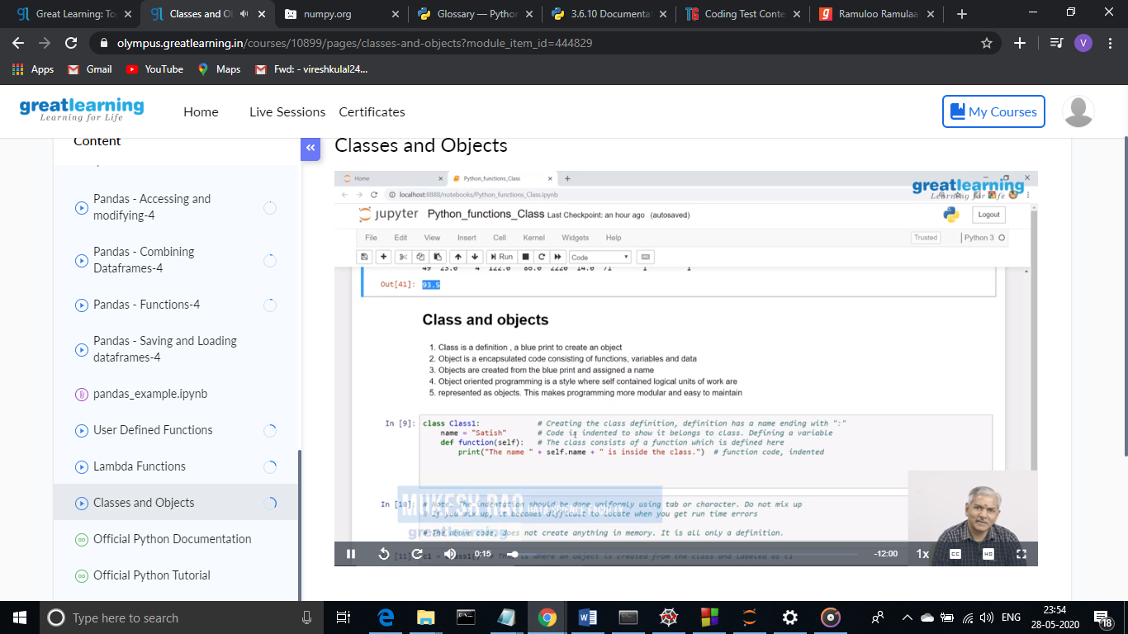

**Online Coding Summary: Today I had received one program from prof. Merlyn Mathias CSE Dept. The programs is mentioned above(pg.01). I have uploaded it to my Github repository.**

The Repository link is:

<https://github.com/viresh-kulal/Lockdown-Coding/blob/master/digital%20root.c>

And the snapshot of the program digital root.c is attached below.

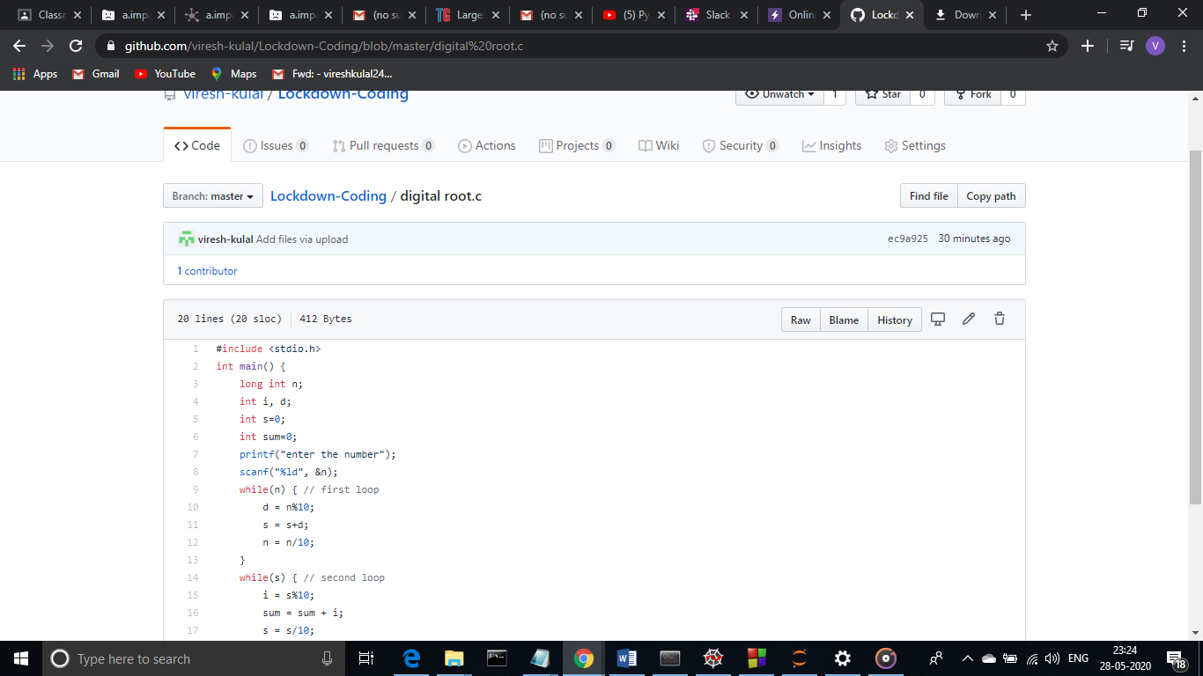**Thank you.**